Computer Language Coding Concepts

System Objects
System objects manage the relation between one object and another. An object can contain related objects. A related object is not the actual target object, but a system object, that controls the target of the related object. An object does not really contain sub-objects. An object contains system objects, that each control the redirection to a target object.

A related object is usually displayed like it is the target object itself. The related object by default shows the members of the target object. But you can also display the members of the system object controlling the target of the related object. In that case it is said, that you are displaying a related object’s system interface. The system interface contains the members of the system object, controlling the target of the related object. This is why we often speak of a system interface, when talking about the members of a system object.

A system interface is the new computer language’s equivalent of Getters, Setters and Property procedures. But the new computer language offers a lot more possiblities than other programming languages to control the behavior of assigning or retrieving a related object.

The articles about the system interface introduce the commands and terminology around connecting objects to eachother. The articles also explain how you can add extra behavior to the connection between objects.

The system interface article group has the following topics:

- Objects Floating Around
- Related Item
- Controlling a Related Object
- Pointer To Pointer
- Symbol
- Object Get & Set
- Pointer To Pointer Get & Set
- Value Get & Set
- New & Annul
- Related List
- Related List Item
- Add
- Remove
- Names of Related Items & Related Lists
- Calling a System Command
- Related Items & Related Lists Collections
- Extending The System Objects
- Summary

Each topic has an article with a conceptual explanation and an article explaining the concept’s expression in a diagram.

Author & Copyright: Jan-Joost van Zon Date: July 18, 2008 – July 23, 2008 Location: Oosterhout, The Netherlands Status: Finished

Ideas
System Objects,

Explain a term such as sub-object and parent
in the system objects article group?
Not now.

JJ

Computer Language,
System Objects

Je moet ook system commands hebben,
die een ->1 related item toevoegen,
en dergelijke. Je moet eigenlijk
alles van het diagram kunnen genereren.
Ik ben geen voorstander van code generators,
maar het moet wel mogelijk zijn.

JJ

Pointers to Pointers,

Perhaps somewhere early in the story you have to explain the primary uses of pointers to pointers. I believe I already have an explanation of that somewhere, but I’m not sure where anymore. Parameters are also generaly pointers to pointers. “To let something else determine the eventual target of the reference.” That might be a good definition.

JJ

<
I think addition, removal, creation or annulment should use a separate display, preliminarily as a plain call to a system command command.

< Picture of diagram >

>

System objects,
2008-07-27

Change the fact, that you can’t use the term symbol as a synonym for related item or related list item. You can use it as such, because it just talks a lot easier. But they are not really synonyms.

JJ

System Objects,
2008-07-24,

Accessing an object requires an Object . Get
Object assignment requires an Object . Get and an Object . Set.
In both cases you do not see a call to a Get or a Set command.

JJ

Nothing,
2008-08

An object reference can have one object or no object at all

JJ

System objects.
2008-08

Another name for an object is an item.

JJ

Coding Concepts,
System Objects,
System Commands,
2008-08-08,

Toegang van het ene object naar het andere met puntnotatie,
is ook een concept.
Je moet namelijk access operators gaan definieren,
en toegang als aparte actie zien, ook om die actie
apart te kunnen access controllen.

JJ

System Objects,
2008-09-16

So under the surface there are only pointers to objects,
and when you think you see a pointer,
it is actually a pointer to a pointer,
or actually a pointer to a related object.

JJ

System objects,
2008-10-01

I have to introduce the term system aspect. I gave it that term in the 2004 Symbol documentation, and I do want to adopt it now.

JJ

System objects,
2008-10-01

< An idea for the system interface is, that for users of an object, you only show the system members that are accessible. I am not sure you always want to see which ones are accessible and which ones are not, because you do not always want to show the system interface. >

JJ

System Objects,
2008-09-20

Introduce the term system aspect:
Object, Class, Value, Existance, Execution…

JJ

System Commands,
2008-09-17

System commands can also be represented by an access connector to a system aspect.
Those would be a representation of the system command definitions.

System command calls would still look like a call.

JJ

System Objects

Object of class zou aan een gebruiker ook kunnen worden uitgelegd als 'context'

JJ

Out of the original Symbol documentation

System Aspects
< I must denote somewhere that lines can be connected so very complexly if sources and targets are reachable from a high ancestor. Say that lines can look orderly, but can also be very complex all the same.>

System aspects are always seen as related to a single symbol. Because of that, the term symbol aspect can also be used.

Line aspects are some of the most important system aspects. The line aspects of an object symbol are:

- Object
- Type
- Interface

And those of a procedure symbol are:

- Definition
- Interface

This kind of aspect is redirected by lines. The Type aspect of a symbol, for instance, represents the direct target of the type line.

Another group of aspects is the target aspects. The target aspects of an object symbol are:

- Target Object
- Target Type
- Target Interface

And those of a procedure symbol are:

- Target Definition
- Target Execution
- Target Interface

These are derived from the line aspects. By doing a trace, the target aspects are retrieved.

Another special system aspect is State, which stands for the data stored in an object, including the line redirections inside an object, or rather: it’s state. A related system aspect is the Created aspect, which points out if the object a symbol represents is created or not.

- State
- Created

These are called the state aspects. {} The aspects here apply only to object symbols, but there are also state aspects for procedure symbols. {}

There are even more system aspects:

- Parent
- Children

- Parent Object
- Child Objects
- Parent Procedure
- Child Procedures

The Parent and Children system aspects can tell you all about the encapsulation structure. Because these aspects again return symbols, you can recursively track down the whole surrounding encapsulation structure. They are called the encapsulation aspects or ancestry aspects of a symbol. The Parent Object and Child Objects system aspects return the object ancestry, kind of like ignoring procedure capsules. The Parent Procedure and Child Procedures aspects return the encapsulation only looking at procedure capsules.

The Shape system aspect returns the shape of a symbol.

- Shape

There are even more system aspects, because system aspects return all information about the symbol, thus all information about the system. I won’t mention the other aspects yet, for they are about concepts not yet explained. Nevertheless, the ones mentioned here are the most important ones.

System Procedures
System procedures, or system aspect procedures, are procedures with which you get and set aspects of a symbol. Every symbol has system procedures. The line aspects of an object symbol are represented by the following procedures:

- Object Get
- Object Set
- Type Get
- Type Set
- Interface Get
- Interface Set

And those of a procedure symbol are:

- Definition Get
- Definition Set
- Interface Get
- Interface Set

With these system procedures you can get and set the line targets of symbols. These system procedures return or take the Symbol Id of the line target: a number that uniquely identifies a symbol.

The Object Get and Object Set procedures together can also be called the Object system aspect or the Object aspect. The same goes for the other aspect procedures.

All system aspects are represented by procedures. Some aspects can only be obtained, not set.

The target aspects can only be obtained, because they are derived from the lines of symbols. The line aspects of symbols can be controlled, but the target aspects can not be directly controlled. So the target aspect procedures of object symbols are:

- Target Object
- Target Type
- Target Interface

And those of procedure symbols are:

- Target Definition
- Target Execution
- Target Interface

The State symbol aspect can be obtained and assigned too.

- State Get
- State Set

The state is obtained to be immediately assigned to another object. That way the values and line targets of one object are copied to another object, giving both objects the same state.

The Created symbol aspect is primarily only obtained, not set. Created can be controlled though, by calling te Create and Destroy system procedures.

- Created Get
- Created Set
- Create
- Destroy

You can set the Created aspect, which is equivalent to calling the Create or Destroy procedures.

Created = True ≡ Create
Created = False ≡ Destroy

But I prefer using Create and Destroy in most cases.

Ancestry aspects can only be obtained, not set. The ancestry structure can change, as type and interface targets change, but the ancestry can not be directly set, except at design time. So the ancestry procedures are:

- Parent
- Children

- Parent Object
- Child Object
- Parent Procedure
- Child Procedures

The Children aspect is actually an array that returns multiple symbols. More on arrays later.

The shape of a symbol can only be set at design time, not at run time, so you can only obtain the Shape aspect, not set it.

- Shape

The last one I’ll mention for now is the Symbol system procedure. It actually returns the symbol itself. More specifically: its Symbol Id. It can be regarded the most primary of all system procedures.

- Symbol

So the system procedures introduced so far are:

Object system procedures:

- Object Get
- Object Set
- Type Get
- Type Set
- Interface Get
- Interface Set

- Target Object
- Target Type
- Target Interface

- State Get
- State Set

- Created Get
- Created Set
- Create
- Destroy

Procedure system procedures:

- Definition Get
- Definition Set
- Interface Get
- Interface Set

- Target Definition
- Target Execution
- Target Interface

General system procedures:

- Symbol

- Parent
- Children
- Parent Object
- Child Objects
- Parent Procedure
- Child Procedures

- Shape

The System Interface
The system procedures of a symbol together form the system interface of a symbol. It is notated as follows:

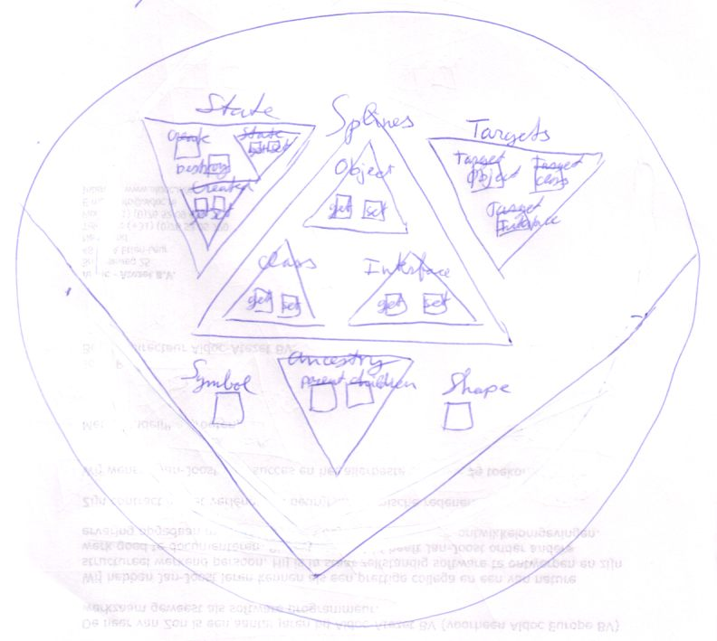  Object System Interface | 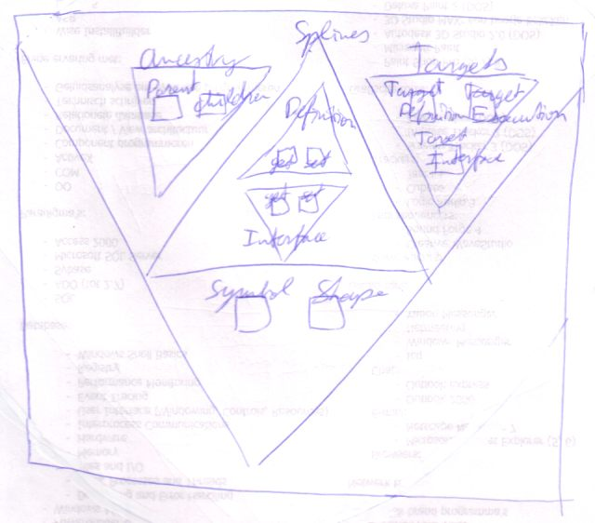  Procedure System Interface

I’ve left out the system procedures I haven’t yet introduced.

In fact, most of the times you’ll only see part of the system interface: only the procedures that are of interest in the view on the diagram, or only the procedures with which something special is going on, while the other ones behave in a standard way. How they can be special and how they can be standard will be discussed later. So a lot of times the system interface might be shown as follows:

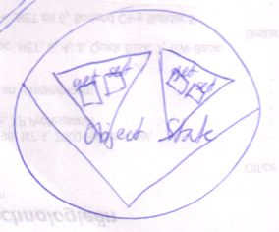

The system interface is displayed sort of like an interface, but tied to the edge of the symbol, rather than being contained by the symbol. This is to denote that this interface is not inferior to the symbol.

The notation of the system interface also looks like you’ve opened up the system and can see its internal wiring.

Notation of the system interface can go together with the regular contents of the symbol.

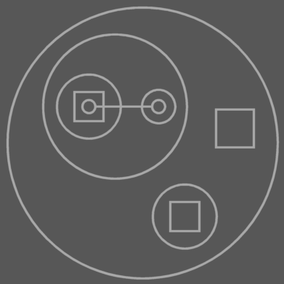  Object Notation Only | 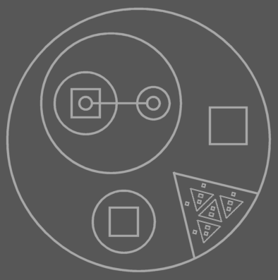  Simultaneous system interface and object members

Calls to system procedures and object members are intermixed, so you have to be able to see both the system interface and the object members at the same time.

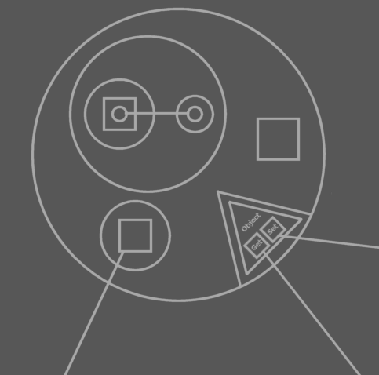
Calls to system interface and to object members

The system interface encapsulates many triangular objects and procedures. However, those objects and procedures are not the same as normal objects and procedures. The members of the system interface are very primary. they don’t have a system interface themselves and you can’t redirect them with lines.

If you see the system interface as an object, though, you can regard the system interface to have the same type for every object symbol. Procedure symbols would have a different system type. All symbols would derive from this system type then.

Get and Set are Inseparable
Get and Set always accompany eachother. That is: there’s no point to getting something if you aren’t going to assign it to something else. Conversely, you can’t set something unless you’ve gotten something in the first place.

Getting a value is done solely to immediately assign it to something else. Get and Set are stuck together with superglue. There is no intermediate state of a value between the Get and the Set. There’s no manipulating a gotten value before you set it to something else.

There are two things you can do with a value: copy it or transform it. If you transform it you always operate on a value directly. Even when you make a temporary copy of the value to operate on, manipulate it and write it back, you’re still directly manipulating the temporary copy. The whole process would be you first Get the original value and immediately Set the temporary copy. Then you manipulate the temporary copy, by calling one of its member or by passing it to a procedure that manipulates it. Then you Get the temporary copy value and immediately Set it to the original object. There is no room between Get and Set.

The combination of a Get and a Set as such is called an assignment.

Which Aspects Can be Paired in an Assignment?
So you always need to combine a call to a Get with a call to a Set. The Get and Set don’t need to be the same aspect. For instance: you can Get the Target Object of one symbol and use it as the Type for another symbol (Get the Target Object, Set the Type).

You can always combine aspects that both return a Symbol Id. State can only be combined with State. The Created aspect can be treated like any Boolean object.

Symbol Ids are stored like an Integer number, but they can not be used as Integer objects. They can only be used among system procedures. You can’t assign an Integer to a aspect returning a symbol and you can’t assign a symbol aspect to an Integer number. So you can’t temporarily store a reference to a symbol inside an Integer.
{Is that true? In that case you can’t investigate the surrounding encapsulation and store it anywhere.}

Note that of the aspects introduced, the only ones that can be Set are: line targets, State and the Created aspect.

All you can do with the aspects that can only be gotten, not set, is assigned it to a line target, State or Created, or Get it for a special purpose, called Access, described below.

Assignment Example
I will cover an example here of an assignment, in which one Get and one Set will be called. In this example, one symbol will be assigned as the type of another symbol.

A simple notation for this is:

[Picture 1]

The diamond is a call to A’s Type Set. B is the parameter to A’s Type Set.

The textual notation of this is also quite simple:

A . Type = B

These are actually simplified notations of something far more complex that’s going on.

The common notation for this is quite easy, but

Brainstorm
Ik wil hier eigenlijk heel goed het gebruik van get en set weergeven. Ik geloof dat het nog niet te vroeg is om gedetailleerd in te gaan op het aanroepen van system procedures, voordat je aspect access control en redefinition uitlegt.

Ik moet hier echt (in de toekomst) heel wat voorbeelden geven, ook in diagrammen. Ik zit in m’n hoofd alleen met. Ik kan in m’n hoofd geen volledige strings met assignments visualiseren, omdat daarbij veel met parameters gewerkt wordt en ik heb nog geen goed beeld van parameters.

But actually all system procedures could be globalized with as parameters the object to operate on. You actually already have such global procedures: the procedures of the system type can be used globally. If you use the system type members like global functions you simply use the type in a non-object oriented way. You pass the object to operate on to the procedure via the this argument. Using the system type procedures as a system interface for all the ‘symbol objects’ is the common conversion from procedural to object oriented.

Get Purposes
<There are also situations in which you want to disallow copying object reference to an argument, but only allow consult of the argument. (that’s access control of system procedures, actually)>

<This is gonna need many pictures. I just don’t draw those system procedure calls very well, yet. I have fear of drawing them>

There can be multiple purposes to Get a value for. You can for instance get one symbol’s Symbol Id, to assign to another symbol’s Type.

Access, Redirection, Copy

Copy of a symbol id gives you a whole set of purposes<>:

- to Type
- to Interface
- to Object

The distinction has to do with access control. For instance: the symbol get might be public to serve as an object, but private to serve as a type. Or rather, the symbol whose symbol get is private for type<> can not serve as a type.

Brainstorm
<And how about Parent get?>
<Maybe if I ask myself the question here, maybe the reader will too, and I have to give a concrete answer to that and to many more things too…>
<I think it’s something for the Get Purposes section>
<I noticed in my type Sigma . Controls . Button Style, I would like to specify separate procedures for copying its Style sub object or accessing the members of its Style sub object, not just separated access modifiers. That’s because if I want to access the Style object’s members, I want to return the Button Style object itself. If I want to copy Style property, I want to clone Me and return the clone. Even worse: if I want to assign a button’s Style and the source is a Style object, I can do a normal object assignment of the aValue argument, but if I want to assign a button’s Style and the source is a Button Style object, then I want .. to do something different. Anyway it’s complex>

Access Control on System Procedures

Variable and Constant

Redefining System Procedures

Exclusive Establishment
< Lines inside uncreated objects, squares and diamonds out of execution, are not real. They are imaginary and only exist when the object is really created.>

- Exclusive establishment problemen moeten in System Aspects worden behandeld

Static, Creation and Destruction
< You have to mention here somewhere what the normal kind of static is and that when explaining situations, you are always seeing members in their normal type of static, and the other types of static are not considered. That way in other explanations lateron, I don’t have to add to every conclusion ‘unless it is static’>

State

Dimensions

Storage of Symbols, Line Targets and Objects

Brainstorm

Summary of Old Subdivision
That introduction:

- System aspect procedures get system aspects
- They return symbol id's
- State is special.
- Other system aspects that might get system aspect procedures.
- Some aspects can be Set
- Setting lines
- Setting State
- Automatic system aspect procedures calls
- Get and Set always accompany eachother
- State assignment
- conversion
- Copy, Access and Redirection purposes
When do they happen?
Every aspects its own collection of get purposes
They're there for access control.
- Fill in system aspect procedures yourself
- System procedures don't have system procedures themselves
- Design time and run time access controllers

- The system interface
- Contents of system procedures
- Contents of system procedures determine lines
- System interface and type code simultaneously
- Showing only part of the system interface

- Call example is shit. Shouldn't come this soon anyway.

- Setting lines
- default implementation
- What get returns determines line.

- Mutual Ancestor is not accurate
because the source symbol can set
a design time line itself

New Subdivision
- System Aspects
Are …
- System Procedures
- Names
- Diagram
- First the main ones: the customizable ones
- Then the secondary ones: the automatic ones
- Showing only part of the system interface
- System interface members don’t have system procedures themselves and you can’t redirect
them with lines
- Seeing the system interface as having a system type.
- Get and Set Always Accompany Eachother
- Get Purposes
- Get
- Copy
- Access
- Redirection
- Use as Object
- Use as Type
- Use as Interface
- Use as Procedure
- Use as Procedure Interface
- Access Control on System Procedure
- Variable and Constant
(Design Time and Run Time Access Control)
(Only at creation or free?)
- Redefining System Procedures
- Default implementation
- Including default access modifiers
- System procedures don't have system procedures themselves
(some aspects are redefinable, some automatic, some automatic but extendable)
- Mention that you can’t really see the system interface as having a system type, if some of its procedures
can be redefined.
(However, lateron, in access control, or procedure resolution, a technique to redefine procedures is given
that make you able to see the system interface as having a system type again…)
- Exclusive Establishment
- Contents of system procedures determine lines
- Static, Creation and Destruction
a.o. Design time lines
- State
- Conversion
- Dimensions
- Storage of Symbols, Line Targets and Objects

- Final Issues
- Immutable at Run Time
- Symbol Roles ?
- Discussion
- A separate symbol for an object symbol that serves as solely as a type?
- Do mind that it’s important that you can have any object symbol as a
type.

New Main Subdivision
- System Aspects
- System Procedures
- Get and Set Always Accompany Eachother
- Get Purposes
- Access Control of System Procedures
- Variable and Constant
- Redefining System Procedures
- Exclusive Establishment
- Static, Creation and Destruction
- State
- Dimensions
- Storage of Symbols, Line Targets and Objects

Other New Brainstorm Items
<How about system aspects that return how many exits a line makes and which symbols it enters?>

Je wilt toch niet altijd de parent aan kunnen roepen? Maar ik wil het toch kunnen bereiken met het setten van design time lines. Hmmm… het is alleen in geval van access dat je de parent daar wilt bereiken.

Het is altijd zo grappig he? Het komt allemaal neer op zulke basale acties. Een hele ton get en sets lijkt het wel. De compiler is meer een plek om hier dieper op in te gaan. Daar vertaal je symbol naar fundamentele processen.

Are implicit calls mostly an alternative notation for get set actions?

------------------------------------------------------

OLD

Introduction to System Aspects
System aspect procedures return the system aspects of a symbol. You can ‘get’ the following aspects of a symbol:
-
- Symbol
- Object
- Type
- Interface
- Target Object
- Target Type
- Target Interface
- State

Symbol returns the id of the symbol itself.
Object returns (the id of) the target of the object line
Type returns the target of the type line and
Interface returns the target of the interface line
Target Object, Target Type and Target Interface return respectively the id of the previously discussed target object, target type and target interface.

State is special and returns a copy of the object as it were, which is a copy of all the data the object stores. This state must be immediately assigned to another object, which is usually of the same type.
All other system procedures return a symbol id; State returns the data of the object. I will return to State lateron.

Similarly even more system procedures could be defined that return more system aspects of a symbol, like:

- Parent
- Children
- Etcetera...

Some aspects of a symbol can also be set. By doing so you change the system (at run time). The follow aspects can be set:

- Object
- Type
- Interface
- State

By setting a symbol’s Object, you change the target of the object line of the symbol. The same way, you change the target of the type line by setting the Type and the target of the interface line by setting the Interface. The State can also be set. You can also remove a line completely by assigning Nothing to the Object, Type or Interface.

A programmer commands when an Object, Type, Interface or State is set. Getting is not always done on direct command of a programmer. When a programmer wants to call a member of an object, he may indirectly cause a lot of Gets to be done. <>On each access that the call makes, the target object and target type are figured out in one string of redirectioning<>. On each of those redirections an Object Get or Type Get is called. When a programmer calls Target Object Get or Target Type Get, the same string of redirections is executed, causing automatic calls to Object Get and Type Get.

The programmer can also initiate Gets himself. This is always done paired with storing the gotten value somewhere, for instance in a variable. So a Get directly initiated by a programmer is always accompanied with a Set.

Working with the State of an object is for instance useful for Integer objects. Their state is the integer value they represent. State is special and returns a copy of the object as it were, which is a copy of all the data the object stores. This state must be immediately assigned to another object, which is usually of the same type. If the state isn’t assigned to the same type then a conversion must take place.

Symbol
Get : Copy
Object
Get : Copy or Redirection
Set
Type
Get : Copy or Redirection
Set
Interface
Get : Copy or Redirection
Set
State
Get : Copy
Set
Target Object
Get : Copy or Access
Target Type
Get : Copy or Access
Target Interface
Get : Copy

When executing a Target Object Get or Target Type Get, automatically are performed Object Redirection Gets and Type Redirection Gets. <other place>

So Gets can have three purposes: Copy, Access or Redirection. Copy Get happens when a programmer stores the gotten value somewhere else using a Set. Access Get happens when the programmer accesses a member of an object. This only happens for Target Objects, and sometimes Target Types too for static elements. Redirection Get happens when tracing the target object, target type and target interface. Each redirection step in this process requires getting the symbol to which there’s redirected. Redirections are never directly initiated by the programmer, but are done automatically.

Every system aspect supports a different collection of get purposes. For instance you can’t get the Object for access. You can only get the Target Object for access. The Object you can only get for copy and redirection.

When the main purpose of a Get is mentioned, the word ‘Get’ is often left out. You can simply speak of for instance Object Copy or Type Redirection.

The reason that this separation between get purposes is made is not that there are three different get procedures. The get procedure of all three purposes is the same procedure so that they return consistently the same value for all three purposes. What you can control separately for the three purpose is their access controller (not covered yet). Redirection is always public: the Symbol system can always redirect whenever it feels like it, because Symbol knows perfectly when to redirect and when not to. You can put restrictions on Access and Copy. If you make Access private then you can’t access the symbol (through its parent). If you make Access public then you can access the symbol. If you make Access public, but Copy private it means that you can access the symbol, but you can’t copy the id of the symbol. To be able to do that, Copy needs to made public. Copy is always equally or less public than Access. One of the main purposes to different access controllers for different Get purposes is to be able to access a symbol, but at the same time not be able to copy the reference to the symbol. The other important purpose is that the Get always has to be public for redirection, even when it’s private for other purposes. You can alter the access controllers of almost every system procedure and purpose, except for Redirection. That one’s always public. Public for the Symbol system that is, because programmers can never call this form of get themselves.

The Get usually returns system information. The Set usually changes a line target normally. However, as a programmer you can also decide for yourself what’s the effect of a Get or a Set. You can totally redefine the Get and Set procedures of a symbol. With that you can also add parameters to the Get and Set procedures. So you’re able to decide yourself which symbol to return on a Get and which symbol to assign on a Set. * You can also for instance see to it that on a Set call, the change is applied to all sorts of things, by starting procedures that apply the new value. When setting an object’s state, for instance, you can automatically apply its new state to other objects, for instance when you need to draw a text on screen every time a value changes. You can’t redefine all system procedures. For instance the effect of Target Object Get must stay consistent and can not be customized. And also Symbol Get always needs to return the symbol itself. You can only redefine the Object, Type, Interface and State Gets and Sets.

Just now, I’ve only discussed the system procedures of object symbols. Procedure symbols have system procedures too:

Symbol
Get : Copy
Call
Get : Copy
Set
Reference
Get : Copy or Redirect
Set
Target Procedure:
Get : Copy or Access

Symbol Get obtains the id of the symbol itself. Call Get obtains the call line target symbol. You can also Set the call target. Reference Get returns the symbol id of the reference line target. You can also Set the reference line target. The Target Procedure of a symbol returns the procedure at the end of the redirection: the procedure definition. Target Procedure Copy copies the id of this procedure. Target Procedure Access is the Get that occurs when you call the target procedure. Access controllers can be applied to all elements, except Symbol Get. Call and Reference Get and Set can be redefined. Mind that the access controller for Target Procedure Access determines the access controller for calling the procedure symbol.

Because procedures have system procedures themselves, you’d think that an system procedure also has an system procedure. That one isn’t true. System procedures don’t have system procedures themselves.

Set and Copy are used to set up lines. Lines are set up at design time, but can also be changed at run time. Sometimes you want to set a line at design time without being able to change it at run time. Therefore, Set and Copy must be able to have different access controllers at design time and run time. Just like the Get purposes can have different access controllers, it’s possible to have different access controllers for Design Time Set and Run Time Set and for Design Time Copy and Run Time Copy. Something is a constant if it can be Design Time Set, but not Run Time Set.

Object symbol system procedures and purposes:

Symbol
Get : Copy (Run Time or Design Time)
Object
Get : Copy (Run Time or Design Time) or Redirection
Set : Run Time or Design Time
Type
Get : Copy (Run Time or Design Time) or Redirection
Set : Run Time or Design Time
Interface
Get : Copy (Run Time or Design Time) or Redirection
Set : Run Time or Design Time
State
Get : Copy (Run Time or Design Time)
Set : Run Time or Design Time
Target Object
Get : Copy (Run Time or Design Time) or Access
Target Type
Get : Copy (Run Time or Design Time) or Access
Target Interface
Get : Copy (Run Time or Design Time)

Procedure symbol system procedures and purposes:

Symbol
Get : Copy (Run Time or Design Time)
Call
Get : Copy (Run Time or Design Time)
Set : Run Time or Design Time
Reference
Get : Copy (Run Time or Design Time) or Redirect
Set : Run Time or Design Time
Target Procedure:
Get : Copy (Run Time or Design Time) or Access

That seems a whole lot of Get and Set purposes. In practice, the set up of a symbol’s system procedures is not that complicated. There’s a standard setup: the most usual system procedure setup. Only deviations from the standard are additionally denoted.

There are a few more system procedures which will be gradually introduced.

The System Representation
The usual representation of an object symbol is one that shows the members of its type.

An alternate look on the object symbol is as a set of system procedures, each granting a different type of access to the object:

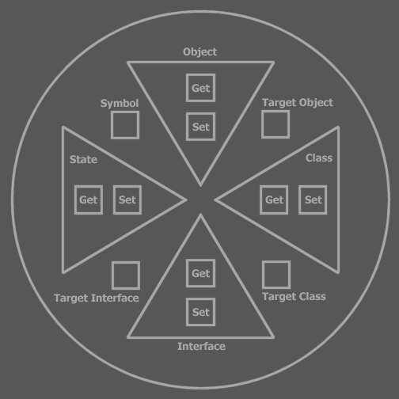

This representation is called the system representation of the symbol. Each procedure in the system representation does what’s discussed in the previous section.

Symbol, Target Object, Target Type and Target Interface only have a Get procedure. The word Get is simply left out in naming these procedure from now on. The word Get can also be left out with Object, Type, Interface and State Gets.

Now you can see that the system procedures are actual Symbol procedures (except that they don’t have system procedures themselves). You can do with them the things discussed above: you can change their access controllers. Some of these procedures can get multiple access controllers for different purposes (System procedures are the only procedures that have this capability.). The Object, Type, Interface and State’s Gets and Sets can be redefined by filling the procedures with code.

Notice that what you fill in in the Type Get procedure, determines the contents of the symbol in the ‘normal’ representation, or type representation, because the type represenation shows the members of the symbol’s type.

The system representation of a symbol has no lines. The lines of the type representation are actually determined by what Get procedures return. Therefore, a symbol is no more than a bunch of system procedures <Interesting, but not entirely true, because it suggests you can determine thw whole system by filling in system procedures, while you can’t directly change the ancestry or change the shapes of symbols. The contents of system procedures determine the lines. The system representation is like seeing the setup of the symbol machine.

Procedure symbols also have an system representation:

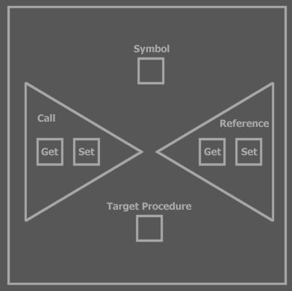

Simultaneous System Representation and Type Representation
You can also view the system representation along with the normal representation. System procedures are called, just like other procedures are called and their being called is mixed with calls to regulare procedures, so you have to be able to see both the system procedures and type procedures at the same time.

The following notation is used for this:

Type Representation Only | Simultaneous System and Type Representation

The system representation is displayed sort of like an implementation of an extra interface, but tied to the edge of the symbol, rather than being contained by the symbol, denoting that this interface isn’t inferior to the symbol. The system representation is in this case also called the system interface. In simultaneous display it is very apparent that it’s system procedures that you’re seeing. It may be preferred to always view system procedures in simultaneous view, even when you don’t display the type contents:



This way it even looks like you’ve opened up the symbol maching in order to change its setup.

Not always the whole system representation is shown. You might only want to show the part that you can see is called

Call Example
< Not finished, but it takes too much time to write this section for now >
< Might need to display how system procedures are called >

I will now discuss the same complex call as before, but now denoting which system procedures are called for which purpose. This call only involves getting values, not setting them.

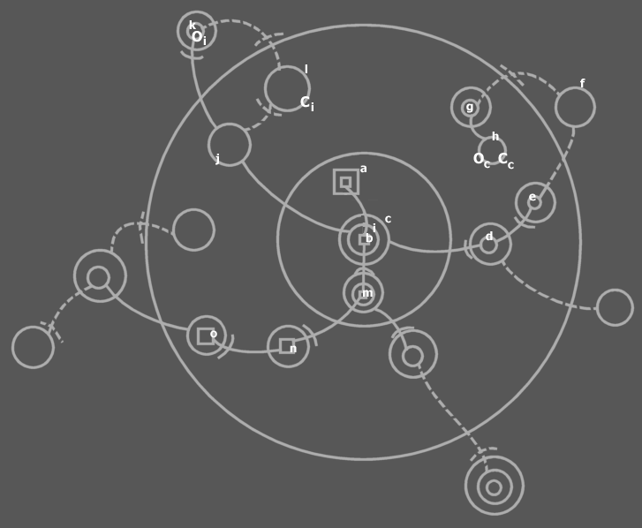

We start at a, the procedure which contains a call, located near the center of the diagram. It calls b, but before that it first acceses c and then i.

c . i . b Is the expression that calls b. The period (.) is an operator, which, as will be explained later, is a procedure call.

The first period is an alternate notation of a call to c . Object. The second period is a call to i . Object. The b that follows is a call to b . Target Procedure. Symbol starts the procedure returned by b . Target Procedure.

Each call of the three (c . Object, i . Object and b . Target Procedure) is processed in steps.

c . Object is called (for the purpose of Access). The c . Object procedure returns d . Object. d . Object returns e . Object. e . Object returns itself: e . Symbol. This process is contained in the Object Get procedures of c, d and e. They redirect to one another until e returns itself. So c . Object returns e.

The target object and target type of e are to be found out. Symbol does this by first calling e . Object Get for the purpose of Redirection. This call is not anywhere in the diagram. It is done on Symbol’s discretion. e . Object Redirection returns Nothing, a special value that in this case indicates that there is no object line. Because there is no object line, the type line may need to be followed. Therefore Symbol calls e . Type for the purpose of Redirection. This call returns symbol f. f . Object Redirection is called, which returns Nothing, so them f . Type Redirection is called, which returns g. g . Object is called, which returns h. h . Object is called, which returns Nothing, so h . Type is called, which also returns nothing. During this redirection loop, Symbol has recorded the target object and target type of e. This concludes the access of c.

Now we know c’s object and type we continue the journey of our call line. It appears in the diagram that we have now entered c. Symbol internally is working with another symbol now, though: h, because it is the target object and type of c.

<… Was here>

Next the call line accesses i. i Redirects to j with an object line. j However has both a type line and an object line. A rule discussed earlier told us that in finding target type and object, a type line is ignored if also an object line is present. So we follow the object line to k. k has only a type line, making it a potential candidate for target object. k redirects to l with a type line. l has no lines. k Is the last symbol to be pointed at with an object line, so k is the object of i: O_{i}, and l is the type of i: C_{i}. Then we roll back to the call line, that can now enter i.

The call line ends up at b, the called square, but b has a procedure reference line to m. Procedure reference lines are bound just as tightly as object lines and type lines and any symbol exits and entrances are irrelevant in processing a call. m Directs to n, n directs to o. o has to be called.

o Has to be called, but it’s a call to a totally different object. You have to know what object you’re calling so you must find out this symbol’s object and type.
Because the initially accessed object isn’t called, but another object, it may seem that performing all those previous accesses wasn’t necessary, but it was. In the target object the procedure reference target is stored, so we indeed needed to obtain the target object, and for that the target type too. This object lead us to knowing where the procedure reference leads. To know which procedure is referenced, you have to figure out its parent’s type and object. So one more obtaining of a target object and type is performed on the target procedure’s parent. This is not an access, but the same method is used.

Setting Lines
The default implementation of a Set procedure stores the target symbol in a storage variable. The associated Get procedure has a default implementation returning it. Lines are determined by what Get procedures return. Lines are always set by calling Set procedures.

This means that setting a line even at design time, requires calling the Set procedures. This section discusses where they are called.

Mutual Descendant Sets Lines
<Mark this as kind of another line restriction, not mentioned in the Lines chapter.>
The line between two symbols is set up by another symbol: the mutual descendant of the source and target symbols.

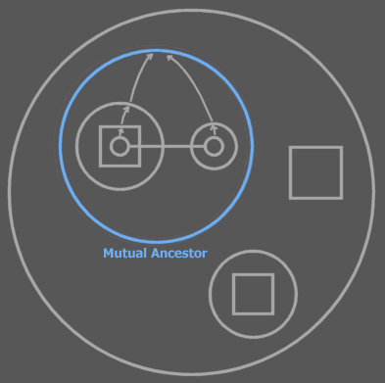

Going upward in the encapsulation for both source and target, eventually you encounter a symbol that they’re both (indirectly) contained in. This is the closest mutual descendant. The closest mutual descendant makes the connection between those two symbols. Even when the line is hard coded, the line is set by another symbol. The closest mutual descendant is the closest symbol that can reach both source and target symbol.

The consequence of this is that the source symbol’s Set and the target symbol’s Copy (Get) must be accessible to the closest mutual descendant, otherwise the line can not be set at all.

In a diagram where you don’t denote publicity, potentially anything is public so lines other than call lines have no limitations to their connections to the outside. When you consider publicity however, restrictions can be laid on these outward lines.

An descendant of the closest mutual descendant (which is also a mutual descendant) could also have set the line, be it that the source and target symbols are published as far up the encapsulation hierarchy. That is: the Set procedure of the source symbol and the Copy procedure of the target symbol must be public to it. Lines set at design time are set by the closest mutual descendant, though.

Lines set at design time are set at run time on creation of the mutual descendant. This means that lines of a symbol’s children only exist in created objects, because line targets are data stored in the created object.

<<
A flaw:

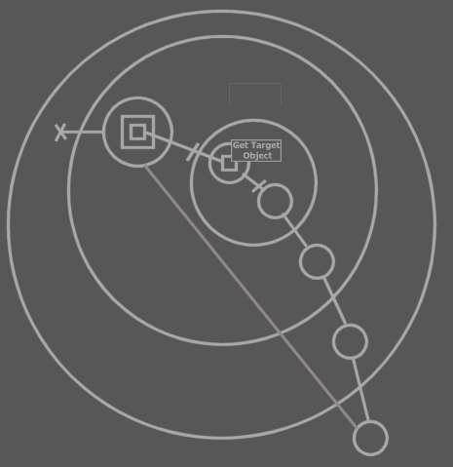

If an object circularity is created and you break an object line in it, then a target object will stand up.

This flaw also occurs when

>>

Create and Destroy
< You can create a symbol giving it an alternate type >

<
Destruction
Destruction is not the opposite of creation. It’s a separate thing, because creation is an operator that is invokes, and destruction just happens when the reference count becomes 0.

Oops. At runtime you can set references to an object, while it isn’t even created… Oops. That’s big. That flaws the destruction methodology.
>

The Create and Destroy Procedures
A subject looked at less closely till now is creation and destruction of objects. The Create and Destroy procedures are actually two system procedures that I haven’t mentioned yet. They only apply to object symbols:

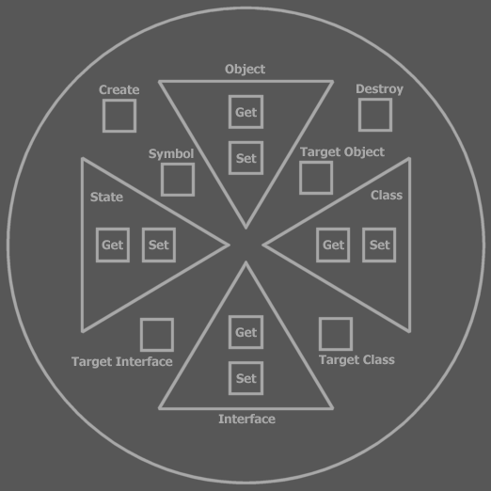

Like the other system procedures, their access controllers can be adapted. There can be separate access controllers for design time and run time, just like Copy Get and Set.

These access controllers are bound to the type, so each symbol of this type gets the same creation access controllers. The access controller of the Create procedure determines which parties will be able to create objects from the type.

Referring to Uncreated Symbols
A symbol can have a line to a non created symbol. So you can reference an object that hasn’t been created. When the object is created, all referrers refer to the created object.

Breaking the Chain
When you break the chain of symbols pointing to a created target object, only certain objects will still refer to a created object:

Only the ones still pointing to this target object still point to a created object. The ones before the break refer to a newly formed uncreated target object. Here you see the concept of direction playing a big role.

Breaking a Bidirection
What if you break the line between the two symbols of a created bidirection? Which symbol remains created and which becomes nothing? The solution is that a bidirection can never be broken in one blow. One direction must be broken first before the other one is broken. Then, when both directions are broken it is clear what symbol remains created and what symbol becomes uncreated.

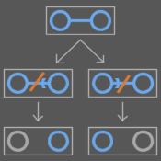

No Lines Inside Uncreated Symbols
Lines are set at run time. Design time lines are actually set in the Create procedure of the mutual descendant. However, in design time nothing is created. So there actually are no lines at design time at all.

Furthermore, lines only exist in created objects, because line targets are stored in the created object’s data. That doesn’t mean that lines can’t point to the insides of an uncreated symbol.

So lines can only exist in created symbols at run time.
So lines can’t exist at design time.

Lines that don’t change during the lifetime of an object can be shown in an uncreated object anyway, so also at design time. You can also show lines in an uncreated object that are set at creation of the symbol. These lines could change after creation. Another method is to show lines that can possibly exist in the lifetime of an object. You can draw the different possible lines in different colors, drawing lines that will most probably exist or exist longer in a more contrasting color. The lines shown there are merely representations of what’s going to happen or what could happen. The lines are instantiated for real only when an object is created.
In created objects, lines are shown that are present for real: exact lines. Inexact, possible lines can also be shown in a less contrasting color (or more transparent). In uncreated objects, lines that won’t change during the lifetime of an object can also be called exact lines.

Destruction
To destroy a symbol, you have to call Destroy on a target object. When you call Destroy on a non target symbol then its object line is simply set to Nothing. The target object remains. When a parent is destroyed, Destroy is called for all children. Only if the children that are target objects are destroyed for real.

Symbol’s Different Methodology for Destruction and Object Reference
There are differences between methodology in Symbol and former methodologies for destruction and object reference.

Symbol’s Destroy is actually like Visual Basic’s = Nothing. It is logical that = Nothing must be called on the last object reference in order to destroy the object. So you have to call = Nothing (Destroy) on the target object. So having to call Destroy is not proof of a less automatic destruction mechanism. It’s just like calling = Nothing on the an object reference.

However, if a target object symbol is destroyed, other references will not point to a created object anymore. In a symbol diagram this makes sense.

 | → | 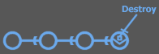 | →

In Com, the object remains as long as there are referrers. Symbol just has a more refined methodology.

Another difference in methodology is that if an object is destroyed, non created symbols still refer to eachother (see picture).

<
How do you mimic Com methodology?
You’d want to make one symbol the object. Other symbols the referrers. The object must
destroy if there are no more references.
>

Creation is not State Assignment
Creation is not a special State assignment. State assignment fills an existing object with new values, copied from another object or derived of another object. It has nothing to do with the creation of a new object. Creation is something totally separate.

Set Example
Here I give the diagrams of how system procedures are called to set a line at design time, change it at run time and anull it at run time.

When you set lines at design time, you’re actually putting code into the Create procedure of the mutual descendant.

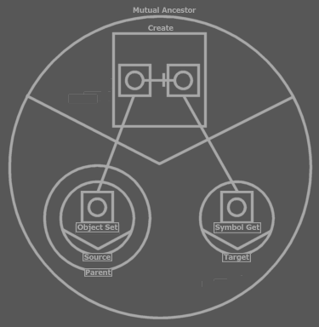

The Create procedure calls Target (. Symbol Get) and then Parent . Source . Object Set passing the result of Target . Symbol Get to it. The text code line would be:

Parent . Source . Object Set = Target

This is a design time set line. You don’t need to display the symbols above all the time and more such symbols for every design time set line. You only have to display the symbols above if you find it really important to display them or when debugging the Mutual Descendant . Create procedure, which sets the lines.

After the Create procedure has executed, the diagram can be displayed as:



The differences are that the access interfaces have collapsed and a line is now between Source and Target. The other diagram showed the procedure of instantiation of the line.

When debugging at any moment a line is changed, you’ll see the source and target symbol’s access interfaces temporarily opening up. When the line is changed, they close again.

Before change:
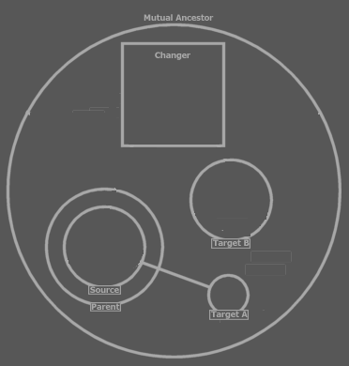

The change:
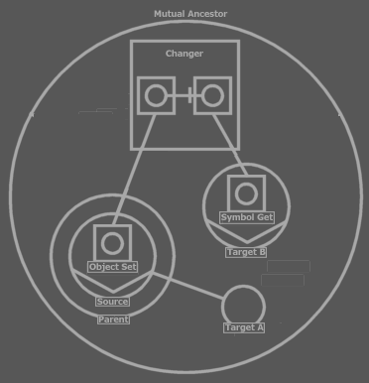

After change:
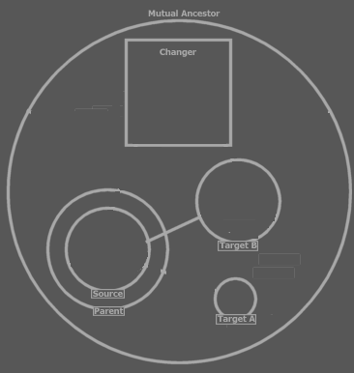

You can also take away the object line completely by assigning Nothing as the symbol’s object, or anulling the line:

Change:
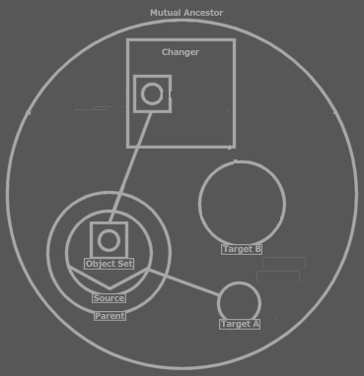

Result:
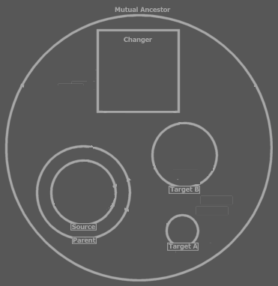

State
State is special and returns a copy of the object as it were, which is a copy of all the data the object stores. This state must be immediately assigned to another object, which is usually of the same type.

What’s actually done is that values from one object are copied to the other object.

- An object’s state includes its children’s lines.
- The states of all its ancestor created target objects are also part of the state.

The states of non-target object descendents are not part of the state. Those symbols point to other symbols. Their line targets are incorporated in the state.

Conversions
If the State isn’t assigned to the same type then a conversion must take place. The target type for the state assignment must define the conversion and this conversion is bound to the state source type; for each state source type, the state target type must define a conversion. If the conversion isn’t defined then it’s not possible to assign a state of that type.

Conversions can also be cast explicitly rather than being automatically performed on state assignment.

Conversion procedures are considered system procedures as well. One type can define multiple conversion procedure’s. The parameter of the conversion procedure is the source object. A conversion procedure can also have multiple parameters. That way multiple objects can be converted to a single object, sometimes grouping multiple object of the same type, sometimes grouping a combination of types.

< If you want to convert a number to text then the text object should define the conversion for all this stuff. Hmm… mayve the source object should be able to define the conversion too >

Conversions Aren’t Create Procedures
This comment is made because in the C++ programming language, conversion procedures are alternative create procedures. A conversion does not involve the creation of an object. A conversion is the assignment of new values to an existing object, values that are based on the values of an object from a different type.

Dimensions (Brainstorm)
<There must be a special notation for a dimensional symbol>
<>
I have to have a substitute for the array in Symbol. It seems that I need the possibility to have a series of multiple object symbols of the same kind. All I might need instead, actually, is the an object symbol with a dimension. I can do that by giving the Object property a dimension. The State property should also get a dimension then. Should I then base the storage of the object symbol on a data structure? To understand this I need to understand the storage of an object’s data. Most of the times, the storage of an object’s data is in the storage of it’s sub objects’ data. Then it goes down the ancestry, usually up until the simple object types such as Integer and Double. Line targets are also stored data, stored Integer objects as sheer identifying numbers. Arrays… are probably symbols of which system procedures have a dimensions, mainly the Object or State property. The system procedure returns something a J Data object returns. I might want to show an alternate notation of a symbol whose system procedures have one or more dimensions.

Maybe I need a small section about object data storage. How it’s delegated to J Data and to Math and that math delegates it to J Data too. I guess J Data is the one to manage the use of space.

I also need a basic explanation about the consequences of giving system procedure dimensions.

Brainstorm
<>
I can not seem to be able to give this sentence a place:
The usual way of accessing most objects is by getting a reference to it and then calling a member of it. The usual way of accessing simpler objects such as Integers is by getting the state of it.

<< Doesn’t the fact that procedures determine lines make the symbol database as I know it invalid? Yeah. Line targets would be far from primary data. What would be primary data then? Object and procedure ancestry and call lines? Yeah. Other lines are data derived from the calls inside system procedures. >>

Immutable at Run Time
<>
What’s never changeable at run time. I think the encapsulative structure. Except for that you can add objects to a series.

And what is changeable at run time.

Static and Creation
< What I call type members a lot, really aren’t type members. They’re object members. Only static type members are type members. And what I call procedure members aren’t procedure members. They are call members. Only static procedure members are procedure members. So what are Type Static procedure members? They are type members that are only associated with a single procedure. Oh, but they are still procedure members than. And then object members can also be called type members. Hmmm… yes, but I overuse ‘type member’ I think. In a lot of places I can say object member.>

<
a symbol apart from an object access procedure also has a type access procedure giving you access to the type members in a static form. The object includes its types static members…(I’m explaining static here)
>

<
Uit dit verhaal volgt dat je wel code als deel van de klasse kan zien, maar dat procedures niet deel van de klasse zijn. Als procedures static members hebben dan heeft elk object z’n eigen procedure type object.

Als types static members hebben dan heeft elke globality instance z’n eigen type object
>

<ik moet makkelijker met de static termen moeten kunnen omgaan>
<An object doesn’t define code. You could say that the type defines code and that a object only defines data. Each globality instance, though, has its own instance of the types of the globalities, even though the code of the types is still only in memory once. So you can’t really say the code resides in a type either.>

- Type static
- Procedure static
- Globality static

- Type static objects
- Procedure static objects
- Globality static objects

- Procedure static procedures
- Type static procedures
- Globality static procedures

- Type Create
- Procedure Create
- Globality Type Create

Memory Reservation
This text is preliminary, because there is no final design on Core object management.

Usually you won’t work with memory management. You’ll simply use for instance Integer or Array objects from the Math and Data modules. Those objects manage memory.

An object that manages its own memory can define what memory spaces it wants. Say it wants 3 memory spaces. You can can then identify these spaces with 0, 1 and 2 in your code. When an object consults a memory space it calls a Sigma Core memory management procedure. It identifies itself and the space it wants to do something with. The Sigma Core stores the real ids of the spaces and knows what space to work with. <> The object doesn’t know its own id, but the caller of the object does. <>

Every time an object is created, it gets its own initial memory spaces. Oh! Once it has one memory space it has the ability to store space id’s of other memory spaces, so then it can work with the spaces with the real space ids. So the Code must store what?

Static
Members usually belong to an object: every object has its own sub objects and procedures. Members of a type that are Static, however, belong to the type rather to individual objects. These members have the same configuration for every instance of the type. A change made to one object of the type changes all objects of the type. The members are considered static to the type.

Procedure instances are made on each call to the procedure. A call is a procedure instance. In order to make objects part of the whole procedure, rather than just the call, procedure members can be made Static to the procedure. On each call to the procedure, the static members retain their configuration.

Static members of a procedure are only the same for every call to the procedure. Static members of a procedure are different for every object that holds the procedure. In order to make procedure members static for the whole type of objects you have to make a procedure member Type Static. When I talk about static procedure members I’m talking about Procedure Static members.

Static type members are the same for every object instance. However, each globality instance has its own copy of static type members. Static type members are not the same for every globality instance. In order to make a type member, or a procedure member static to the any globality instance, you make the member Globality Static.

An effect of making type members static is that you can call the members even when the symbol isn’t created. Non-static members, or instance members, can only be called on a created object. Globality static members can be called even when the globality instance isn’t created, but the globality type is loaded into memory. Static members of a procedure can be accessed without running the procedure.

Procedure static members are like part of their object. They persist for as long as the object is created. Type static members persist for as long as its globality instance is created. Note here that each globality instance gets its own set of types with static members. Globality static members persist for as long as the globality type exist. A globality type exists when the Sigma module that contains it is in memory.

Type Creation
The Object Create procedure initializes the instance. In it you can create sub objects, set up lines and call members. Type members are initialized in another procedure: Type Create. The Type Create procedure of a symbol is called when the type is created. Types are created when a globality instance is created so the Type Create procedure of all types in a globality instances are called right after the globality’s Object Create procedure.

You can only call static type members in the Type Create procedure, because non-static, object members can not be accessed yet, because they can only be accessed through a created object.

A procedure has a Type Create system procedure as well, to set up the procedure’s static members.

Members of a procedure that are Type Static are initialized in the type’s Type Create procedure. Any Type Static member, be it of a procedure lives as long as its type. Type Static procedure members are like type static type members, except that they are accessed through the procedure. If the procedure declares them private, they are accessible only to the procedure itself.

A globality also have a Type Create procedure. This is called when the globality type comes to light. Globality types come to light when a Sigma module is loaded. All the Type Creates of globality types in a Sigma module are called right after the Sigma module is loaded. The Type Create of the main globality of a Sigma module serves as the module initializer. The Object Create of the main globality serves as the module instance initializer.

Old

Creation

Globality Creation
…

Static Objects

Type Static Objects
Sub objects belong to their container object. Static objects, however, are part of the type rather than part of individual objects. Each object then contains a sub object that is the same for each object of the type. The static object symbols are shown to all point to the object in the target type. The static object in the target type can be created while the type symbol isn’t shown as created. The target type holds the line targets and data of the static object. When an object of the type tries to change the object line of the static object, it doesn’t change the line of its own object symbol, because that line will always point to the static object of the target type. Instead, the line of the static object of the type changes.

This makes it so that lines can be tied together quite complexly, because static object symbols in object of the type always point to the static object symbol in the target type, which can be lines that travel far. On the other hand: every object of the type with a static object can set the line of the static object, meaning that the static object can point to a wide variety of locations, so it could again be a far away line. The lines of the static object symbol inside objects of the type, that point to the static object symbol of the target type, anyway, these lines don’t really exist. I still must come up with a way to make the notation different so that you can see the static systematics.

Procedure Static Objects
Procedures are much like types. They can hold objects too. If you want the state of an object to persist for multiple procedure calls, you can make the procedure object a Procedure Static.

A procedure static object does give every object of its type its own procedure static object.

By making a procedure’s object both Procedure Static and Type Static, the procedure object is the same for every call to every object of the type.

Procedure and Type Static objects inside procedures can also have the long lines going from all objects to the type.

<P>

Globality Static Objects
A Type Static sub object is the same instance for each object of the type. But each globality instance gets its own Type Static object. If you want the object to be the same for every instance of the globality, then you must make the object Globality Static.

Note that Type Static Objects that are direct ancestors of the globality are static to the globality type so automatically Globality Static.

Note that Globality Static objects are automatically also Type Static.

Static Procedures

Procedure Static Procedures
If you not just make a single procedure object Procedure Static, but the whole procedure Procedure Static, then all objects in the procedure are Procedure Static.

Type Static Procedures
If you make a procedure, not an object, Type Static, then the procedure static objects inside the procedure are also static for the whole type.

Another effect of making a procedure Type Static is that you can call the procedure even through an object that isn’t created.

Type Static objects and procedures can be accessed even though an uncreated object symbol, but non Type Static procedures and objects can not be accessed unless the object symbol is created.

Globality Static Procedures
The rules of Type Static procedures also apply to Globality Static procedures. Only Type Static procedures’ objects are static to all instances of the globality.

Type Create and Destroy

Type Create and Destroy
In order to initialize and terminate objects and procedures static to the type, object symbols have a Type Create and a Type Destroy system procedure. The Type Create procedure of an object symbol is called long before the object symbol is created and becomes a created object. The Type Create procedure is called when a globality object is created. The Type Create procedures of any ancestor object symbol of the globality is called, but not of the object symbols in sub globalities. Those object symbols’ Type Create procedures are called only when the sub globality is created. Many object symbols might not even have a Type Create procedure.

The Type Destroy procedure is called when the globality instance is Destroyed. Beware not to uninitialize Globality Static members of the type, because those belong to all instances of the globality, not just the instance of the globality that’s being destroyed.

Note that you can only initialize the members static to the type in the Type Create procedure, not instance members. This is not a restriction that the Type Create procedure imposes. It’s just that the Type Create procedure is called before any object is created and you could only access non static members through a created object, so at the time the Type Create procedure is run, instance objects and procedures are accessible.

Type Create is stuck right at the end of the globality’s Object Create.

Type Static members are like part of the globality instance, rather than the object instance.

Globality Type Static members are like part of the Sigma module, rather than the globality instance.

Globality Type Create and Destroy
Globality symbols also have a Type Create. New globality types come to light when a Sigma module is loaded. All the Type Creates of globality types in a Sigma module are called right after the Sigma module is loaded. The Type Create of the main globality of a Sigma module serves as the module initializer. The Object Create of the main globality serves as the module instance initializer.

Procedure Create and Destroy
Procedures are in many aspects the same as types. To initialize the static members of procedures. Procedure Create is called on creation of the procedure’s object. In the Procedure Create you can only call static members of the procedure, because the instance members of procedure only exist during a call to the procedure.

Procedure Create is stuck right at the end of the object’s Object Create.

Procedure Static members of a procedure are like part of the object instance, rather than the procedure instance.

Question
Where are type static procedure members initialized?
Type Static procedure members are like part of the globality instance. They are globality instance specific, but this is also called type specific, because a type belongs to a globality instance. They should be initialized along with the globality instance, so along with the type creation. Type Create can access Type Static procedure members and are initialized there.

Type Static members of both the type and its procedures are initialized in the Type Create procedure and terminated in the Type Destroy procedure.

Globality Static members of both globality, its type and procedures are initialized in the globality’s Type Create procedure and terminiated in its Type Destroy procedure.

Old
<
Object data
An object has its own data. Data is accessed through the objects’procedures or through the procedures of its sub objects.
>

Objects and Memory Reservation
Objects reserve memory when created. In this memory their data is stored, data which represents the object. The data is manipulated in the procedures of the object, by calling basic memory management procedures. Objects you program usually don’t reserve this memory themselves. Memory is often only reserved by contained basic data objects, such as Integer or Double. They manage memory reservation and management. When those basic data objects are created, they reserve memory. The descendant can create them in its create procedure, but also at a later time. The descendant can also just allow creation of its contained objects.

Type Static
The basic things about a static procedure:
- Callable even when the object symbol isn’t created
- Data mutual for every object

The first point is just a matter of tagging it static.

The second point:
The type should contain objects that store data. How do they belong to the type rather than the individual objects? Make all system procedures static? What does that render? That makes the procedures accessible when the descendant isn’t created.

Aleen als de naar hetzelfde geheugen verwijst.

Ik volg het niet. Ik zie het niet.

Only Procedures of Created Objects can be Called
You can not call procedures of a symbol that isn’t created just like that. Therefore you can’t refer to a sub symbol of an uncreated descendant using any kind of line.

Static Members
There is a way to call procedures of a symbol that isn’t created: you can make procedure’s static. This makes them callable even when the symbol is not created. They are the type’s members rather than the object’s members. An object symbol becomes static by making one or more of its system procedures static, for instance the Symbol Get, which makes you able to link to an object symbol. You can call the type’s static members through any symbol that has that type. Static procedures aren’t passed the hidden object argument.

Type Create and Type Destroy
You may want static objects to always be created. Remember that static objects are objects some of whose system procedures are static. Those static objects can store static data for the type. Or you may want to reserve ‘static’ memory space for the type yourself. There’s no such thing as static memory space, but you can allocate memory and store a reference to it in a static object. To be able to have sub objects created as soon as the type is running, a type, apart from an object, needs a Create procedures. Therefore, object symbols have a Type Create procedure. Object symbols also have a Type Destroy procedure to be able to destroy static objects and deallocate static memory.

Types’ Creation
The Type Create and Type Destroy system procedures can’t be called in your code. They are only called by Symbol automatically, just like Object Redirect is only used by Symbol itself. Type Create procedures are called when the direct globality of it is created. So when a globality is created, any Type Create procedure of any object symbol inside it is called.

Type Create and Type Destroy are Static nor Non Static
The Type Create and Type Destroy are considered static nor non static, because because Type Create is called before the type is created, so before static members can be called.

Globality Static

Other Issues
Globalities need to be created too.

Globalities can also have static members. Those are members of the module that can be called even when the module is not created. The globality type create procedure of all sub globalities is called as soon as the module is loaded in Sigma.

Types in a non created globality can usually not be referred to.

There can also be static members of a globality. Those are mutual to all globality instances and can be referred to even when the globality isn’t created. Then you can refer to procedures (and objects and types) of a non created globality. The procedures must be made Globality Static in order to do that. Globality Static symbols’ Type Create procedures are called even when the globality isn’t created. To have objects run as soon as the globality type runs, the globality symbol has a Type Create and Type Destroy procedure as well, in which you can create objects to run staticly.

Types of globalities can be

Then globality static type creates should be called when the sigma module loads. Right. The module only exists when. So globalities must also have their own (Globality) Type Create and Type Destroy procedures that are runned when the Sigma module is loaded, respectively unloaded.

So now there’s not only static symbols, but globality static symbols, which can be members of ancestors at any depth inside the globality. Only globality static members (including system procedures) can be called when a globality is not created.

Sub globality’s type creates are also called on module load. If you don’t define globality type create of syb globalities, then nothing is called ofcouse. Only if you choose to have a globality with globally static data, their globality type create procedure is called.

Sub globality’s type creates are also called on module load. Sub globality type creates are called in the super globality type create. In a globality type, Type Create procedures that are declared Globally Static of object symbols are called when the the globality type is created.

The creation of a globality must be initiated by code, because a globality symbol can also become a globality reference, in case of which Create must not be called.

Dus globally static procedures kunnen worden aangeroepen nadat module is geload. Alle globally static procedures van alle.

- Globally static procedures
- Type Create procedure of globalities
- Static procedures
- Type Create procedures of object symbols
- Object Create procedures of globalities
- Object Create procedures of object symbols
- Static procedures directly in globalities

Symbols always contain some data: their line targets. Those are static data, so when you create a globality there’s always memory reserved: for each symbol memory that stores the line targets. (by the way: doesn’t a flag need to be stored to on if the symbol is created?). Or should I store line targets in the Core’s object table? Hmmm…

Static bij procedure members.

< How can you make a type: globality static? >

Symbol Roles
- base
- base type
- base object
- base interface

Procedure Symbol Roles
A call line makes the square a call. A reference line makes it a reference. No line at all indicates that it’s a procedure definition or a clause. Lines can also be left out for abstraction reasons.

  Definition |   Clause |   Call |     Reference |   Illegal: a square can’t be both a call and a reference

< Not true: a call doesn’t have to directly exit a square if it calls a procedure reference embedded in the same procedure or a clause of the procedure>

Note here that the access symbol of a solid procedure reference line is also drawn solid.

Reference and Call Targets
Here is a list of possible reference targets and call targets:

  Reference to definition    Reference to clause    Reference to reference |   Call to definition    Call to clause    Call to reference  (A call to a reference calls the referenced procedure)

Accesses
< This section explains too much on traces that has already been explained in Lines. I also think that which traces are involved in an access is not for now. You might have to know what’s considered an access, so that you understand aspect procedure call purposes, but that’s all >

Before going into detail about system aspects, I have to define a basic concept: an access.

On a call you enter zero or more objects, going deeper into the ancestry or staying on the same level. Each border you enter is called an access.

An access is where a call line enters an object symbol.

So access only takes place in the line of execution when one procedure calls another.

In my further explanations I’ll take the following form of call as a base:



A call to a child’s procedure.

In our basic call, you access one symbol:

Accessing the object requires an object-type-interface trace.

Each of those steps is called a redirection and they are part of the same access (the accessing of R).

Accesses
Any access (a call line’s entering an object symbol) involves such redirectioning, in order to know which type to call, to operate on which object. If you access multiple symbols on one call, each access includes its own object-type-interface trace.


Great grandchild access requires three accesses.

Once we’ve processed each access by following redirections, we’re not even done. When we’ve finally reached the procedure to call, we might have more redirections to follow: procedure reference lines.

<P: Reference line entering object symbols>
The point at which a reference line enters an object is not regarded an access. A reference line between two procedure symbols is a tighter bond than a call line. The borders of symbols that the reference line enters are simply in the way. The procedure symbols are directly tied together.

<P: Reference target has a reference target itself.>

When you’ve reached the reference line’s target symbol, this target symbol may have another reference line. In order to find out if it does, the object and type of the object symbol that holds the target square must be tracked down, because the object stores the line targets of its procedure.

A reference line’s entering a symbol is not another access, just like any other line entering a symbol is not another access either, even though it involves tracking down of object and type. Tracking down object and type is a more common thing than an access. It’s merely involved in an access, rather than being the access itself. It is also involved in figuring out a procedure reference line target.
Every step in finding the procedure reference target involves tracking down a type and object. The reference lines must be followed until you find the target procedure and then that’s the procedure to call.

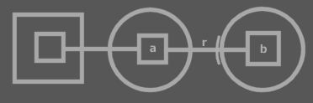

This is a call to a child’s procedure. After reaching the child’s procedure, the redirectioning isn’t done, because the child’s procedure has reference line (r), which is to be followed. Eventually b is called.

When the target procedure is found, it needs to be called. In order to do so, object and type must again be traced, in order to know which procedure of which object to call. This again isn’t an access, but the same kind of process is involved: the process of finding the target type and target object of a symbol.

A Complex Call Example
Here follows an example of one call with a ridiculously large amount of redirections of all sorts. We’re going to follow it in detail.

We start at a, the procedure which contains a call, located near the center of the diagram. It calls b, thereby first accessing c. c Redirects to d with an object line. The entering of another object symbol there, is not another access. c And d are tightly bound together and go beyond any exits or entrances. There are restrictions as to how such a tight bind is established, but those issues are covered later. d Redirects to e with an object line. Again, the exit of an object symbol and the entrance of another one is not relevant in the process we’re discussing. Then e is bound to f with a type line, making ‘e’ a potential candidate for target object, but only if no other object lines will present itself in the redirection. f Redirects to g with a type line. g Redirects to h with an object line, upon which e looses its candidateship for target object. h Is the end of the redirection so h is both c’s object as well as its type, we give h the alternative names: O_{c} (object of c) and C_{c} (type of c). Now we know c’s object and type, we roll back to the access of c, and we continue the journey of our call line. Only one access has just taken place. The other steps were redirections followed for the access.

Next the call line accesses i. i Redirects to j with an object line. j However has both a type line and an object line. A rule discussed earlier told us that in finding target type and object, a type line is ignored if also an object line is present. So we follow the object line to k. k has only a type line, making it a potential candidate for target object. k redirects to l with a type line. l has no lines. k Is the last symbol to be pointed at with an object line, so k is the object of i: O_{i}, and l is the type of i: C_{i}. Then we roll back to the call line, that can now enter i.

The call line ends up at b, the called square, but b has a procedure reference line to m. Procedure reference lines are bound just as tightly as object lines and type lines and any symbol exits and entrances are irrelevant in processing a call. m Directs to n, n directs to o. o has to be called.

o Has to be called, but it’s a call to a totally different object. You have to know what object you’re calling so you must find out this symbol’s object and type.
Because the initially accessed object isn’t called, but another object, it may seem that performing all those previous accesses wasn’t necessary, but it was. In the target object the procedure reference target is stored, so we indeed needed to obtain the target object, and for that the target type too. This object lead us to knowing where the procedure reference leads. To know which procedure is referenced, you have to figure out its parent’s type and object. So one more obtaining of a target object and type is performed on the target procedure’s parent. This is not an access, but the same method is used.

Brainstorm
A funny thing about state get is that it has a return value that is an object, nor a procedure. It’s so fundamental, there isn’t a symbol representation for it. ?Other system procedures at least return an integer number?

Ik met echt nog wel meer operator style behandelen.

All Object Symbols that are the same Objects have the Same Line Targets
Object stores line targets (except for type members, those are stored in the type). So any object reference has the same line targets. It the object shows that one of its members has a line, that member of other object references has a line to the same target.

System Procedures for Globalities
System procedures of globalities are the same as for other object symbols. The only restriction is that globalities can’t have lines to objects and objects can’t have lines to globalities. Globalities can have an object line, type line and interface line just like objects.

New Name for System Procedures
Aspects / System Aspects?

Eigenschap. Karakteristic
Facet
Property
Characteristic
Aspect
Attribute
Determinator, determination
Determinant
Decisive
Systemizer
Formant
Formulator
System
Structure
Coordination
Regulate
Structor
Format
Formation
Formater
Syntax
Configuration

Klep open
Motor
Een beest een bloem een plant een instrument een ding.
Knop
Stopcontact
Stekkers
Bedrading

Wiring
Cords

Klink

Openbaar
Wiring
Infrastructuur
Wegen
Straat
Vertakkingen.

Infra

Wegenmaker

Wegbouw

Channel
Path

Volgen
Follow
Media
Stroom
Waterways

Knoppen
Wiring
Channels
Wire
Cable
Line
Lead
String
Thread

To Do
I have to involve text code in explanations about access.
What about interface lines
What about calls to clauses?
Well… maybe if calls to clauses doesn’t work too well I may just forbid it…? Does that have major consequences?

Wow, this also involves GETTING information about the diagram at run time too.

Remarks
- Constant parameters is totally missing. I think they’re missing in the C++ summary too!
- I think I still didn’t cover static yet.

- In the C++ programming language constant parameters can be set at run time when you call a procedure. In Symbol constants are really constant: they will not change at run time and are only set at design time

Exclusive Establishment

Brainstorm: How are Line Targets Stored?
Vraag 1:
Waar en how worden line targets opgeslagen?
- In een Line Target object <geen goede naam>. Deze klasse bevat een Exits Integer en een Entrances Integer Array. De Exits Integer slaat het aantal exits op. De Entrances Integer Array bevat de ordinalen van de symbolen to enter. Een ordinaal is het symboolnummer binnen zijn parent.
- Elke line wordt zo opgeslagen binnen het object dat de line bevat.
- De line source hoeft niets te weten van zijn omgeving en de inhoud van children of cousins om er toch naar te verwijzen
- Pas als de echte line crossings (hoe heten deze symbolen die gecrossed worden?) moeten worden achterhaald, dan worden er traces uitgevoerd. Dit gebeurt bij opvragen van informatie over een symbool (? Oh ja? Krijg je niet gewoon de Line Target object terug? Of krijg je dan wel unieke symboolnummers terug of zo?), bijvoorbeeld bij het uittekenen van het systeem, of bij een call.
- Dit heeft tot gevolg dat bij veranderingen in het systeem, de line target naar onbedoelde symbolen verwijst. Daarom worden bij bepaalde systeemveranderingen (optioneel?) de line sources opgeheven(, of tijdelijk onschadelijk gemaakt?) <moet de term line source niet ergens geïntroduceerd worden?>
Dus krijgt elk zichtbaar symbool toch een nummer? Ondanks dat sytematiek opgeslagen is in de object klasse van de globality klasse?

Elke opslag entiteit krijgt een nummer. Een opslag entiteit wordt gerepresenteerd door een symbool. Een gewoon object is een opslag capaciteit. Ook een call is een opslag capaciteit. Een klasse ook, voor de type static delen. Een globality object ook, en een globality klasse ook. Binnen deze opslag entiteiten worden line targets opgeslagen. Wat voor nummer krijg je nou terug bij het aanroepen van een aspect procedure? Niet een opslag nummer, want meerdere symbolen kunnen dezelfde opslag representeren. Hmmm… Ik weet het niet.

I guess each symbol must get its own id, somehow. Recursion is not a problem in this, because recursion doesn’t create infinity, it only creates ~ possible infinity. Each symbol getting an id may be bad when the system changes at run time.

In vele gevallen hoeven er geen symboolnummers te worden gegenereerd in run time. Voor dingen die publiekelijk in de module veranderen kunnen, moeten er dan symboolnummers worden gegenereerd.

Werkt dat wel? Met symbool nummers? Hoe wordt een symboolnummer gekoppeld met een symbool?

Het probleem is nu: wat krijg je terug als je een system aspect procedure aanroept? Hoe identificeer je een symbool enkel symbool?

Het identificeren van een symbool wordt bemoeilijkt doordat een symbool makkelijk van klasse en van interface kan veranderen, waardoor een ander set symbolen ontstaat.

Een line geld voor de hele opslag entiteit van de line source. Als lines naar buiten gaan dan wordt het moeilijker, omdat 1 object bijvoorbeeld zich kan bevinden in 2 compleet verschillende parents. Een line naar buiten kan naar de ene parent z’n inhoud gaan, maar net zo goed naar de andere parent.

[Picture 1]

Het opslaan van zo’n Line Target object heeft dus geen zin.

Je moet altijd naar een symbool wijzen in een gecreëerde opslag entiteit. Dus een line target is geïdentificeerd met het symbool in de opslag entiteit. De line source zit ook altijd in een gecreëerde opslag entiteit. Als een gecreëerde opslag entiteit al zijn sub symbolen nummert…

[Picture 2]

Wijs je nou naar een symbool van een object of naar een symbool binnen de referentie van een object?
Nee, dan krijg je verschikkelijke diagrammen.

[Picture 3]

Dat is dus niet waar. Een line wijst naar een symbool in een object referentie, niet naar het symbol binnen het object. Dit gaat niet eens alleen over wijzen naar buiten, maar ook over wijzen naar binnen.

Maar wijzen naar binnen is gemakkelijker, want wijzen naar buiten kan

Oh, als je niet alleen het aantal exits opslaat, maar de symbolen die geexit worden? Oh, maar welke ordinalen krijgt die dan. Uhhmm…

Hè! Shit! Lines opslaan is moeilijk.

Ze worden binnen een opslag entiteit opgeslagen. Nu is het nog onduidelijk hoe de target wordt geidentificeerd.
Het is alleen moeilijk voor binnengaan en verlaten van object symbols. Of niet? Hè, fuck. De target moet gecreerd zijn, maar wijst naar een referentie

Ik weet niet hoe een target wordt opgeslagen. Ik weet niet hoe een referentie wordt geïdentificeerd.

Referenties zijn inderdaad aparte entitieten en ze verdwijnen en ontstaan bij het veranderen van type lines, interface lines en ook object lines als de klasse of interface van een symbool verandert.

Dus er moet dus maar rekening mee gehouden worden dat als je een symbool van klasse of interface doet veranderen, dat dat gevolgen heeft, vooral als je het extern kan instellen met weinig beperking. Als een symbool van klasse of interface verandert, dan moeten er oude symbolen worden gederegistreerd en nieuwe symbolen worden geregistreerd. Maar hoe koppel je dan die symbolen met hun id. Nou, de registratie zit gebonden aan de parent. Dus je moet het symbool toch identificeren met zijn parent en eventueel grandparent. Dus met een heel pad. Maar hoeveel identificaties je nodig hebt is afhankelijk van de scope. Je identificeerd alleen de diepere containers.

OH! Inderdaad wordt elk symbool in de Symbol database opgeslagen! Aleen als je van klasse of interface verandert, deregistreer en registreer je symbolen. Shit hé, kan je dan toch een symbool met 1 nummer identificeren? Ja. Maar het zit zo: hoe kom je van nummer naar oord en van oord naar nummer? Nou, de relaties tussen de symbolen zitten in een boomstructuur opgeslagen. Je kan met de symbol id naar de parents en children hoppen.

Dus, oh, fuck. Ondanks veranderbaarheid van het diagram staat toch elk individueel symbool (dus ook individuele referenties naar hetzelgde object) apart geregistreerd. Je kunt dus alle symbolen identificeren met een nummer.

Als dan dus een line target verwijst naar binnen ergens en opeens verandert de inhoud en bestaat de target niet meer, dan worden de source symbol’s lines maar geannulled.

HEH. Volgens mij ben ik eruit. Je kunt gewoon symbols line targets met een enkel nummer identificeren. De symbol database (in design time, dan) is ook weer wat duidelijker.

Elk symbool krijgt een registratie. De boomstructuur wordt opgeslagen. De lines worden opgeslagen in opslag identiteiten. Elke opslag identiteit krijgt ook een registratie. Als klassen of interfaces veranderen, dan worden er symbolen geregistreerd en gederegistreerd. Een opslag identiteit verdwijnt of verschijnt ook door het veranderen van lines.

Even though a lot of the encapsulation structure can be derived by following type and interface lines, every individual symbol requires a registration, because each symbol can be individually pointed at.

In a call the source and target symbol are tied together with a tight bond. What traces are required now I know that line targets are bonded closer? Well… I’ll find out.

Brainstorm
Oh, making type unsettable at run time can be considered a form of genericity. Maybe I should even rename the other type genericity I mentioned. It might be called object-type genericity. Well… settability can also be called variable and constant.

See to it you mention that an explicit type does not fix the type permanently unless you make the Type Set of the symbol Runtime Inaccessible. Oh, haven’t covered access control in detail yet, but that’s not a problem really.

Before going into

< A Target type can also be called a type definition. The target procedure can be called the procedure definition>

< Apart from brainstorm items scattered around the toughest tasks are:
- Dimensions
- Static and Creation
>

< If I’m to make a chapter ‘system procedures’ It should cover ALL system procedures.>

< Ergens deze zinsnede:
the Symbol Get, which makes you able to link to an object symbol
>

<< Access Modifier Get and Set are not mentioned in this sub chapter>>
<< Introduce the term Property in this section. And use it further down. Or find a better word for property. >>

I also wanna cover how lines are set and what happens when … now I forgot what invalshoek I was talking about.

<Define exclusive establishment and establishment exclusion somewhere>

Brainstorm

→System Aspects
This Argument
<Also discuss the way to call a type’s members directly, while they are ‘object static’ (I haven’t introduced the term object static yet, I used to call it non-static, but object static seems to fit well in the system). So, discuss calling a type’s object static members directly, filling the this argument with a reference to the object. Then you also need to figure out a notation for this call when you see the call line. How do you see the this parameter inside the type, or do you only see it on the call to the type’s object static member?>

→System Aspects
Passing a clause by reference
Procedure ( Parameter . Reference Set ( Value . State = … ) )

Dat is de uitgebreide notatie, in ieder geval. Een wat gebruikelijkere notatie is:

Procedure ( Parameter . Reference = … )
>

→System Aspects
Exclusive Establishment
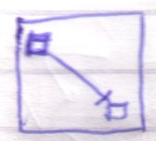 | Reference to sibling inactive clause, in a square  Only possible for static procedure members or exclusive establishment.
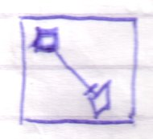 | Reference to sibling active clause, in a square  Only possible for static procedure members or exclusive establishment.
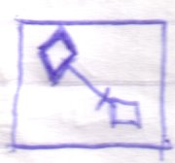 | Call to sibling inactive clause, in a square  This is like a jump to a clause, that would otherwise not execute.  Only possible for static procedure members or exclusive establishment.
 | A diamond can be executing. Only during the execution of the diamond, lines between its non static children can be real. If the diamond isn’t executing, or it’s not a diamond, but a square, lines between the non static children are suggestive. Only lines between static members in such cases, can be real.

→System Aspects
Exclusive Establishment
Or to inside static (or to outside : its static, or its exclusive establishment) <?to inside never exclusive establishment because that’s determined by parent.?>

Oh, a reference pointing out of a square is possible only for static symbols, because normal, non-static references to the outside are established on a call. A square can not contain a non-static references to the outside. A diamond can.

If a clause can access anything outside then you should be able to have exclusive establishment of a line going out of a square. But this has the consequence that references to the clause could access things out of the clause’s parent. Well.. this is ok. If it isn’t a clause, but a reference, there is no possibility of this exclusive establishment of a line going out of a square unless the line target is reachable from the definition. <Create the picture in your head as you read that. Anyway, I disagree. It doesn’t matter that it’s reachable by the definition or not. All that matters is that the one setting the line could reach both source and destination. It doesn’t matter if the line source can access the line destination. Funny enough, that does matter. The line talked about is still exclusive establishment, not real, but it can be there as an imaginary line. No problem>

→System Aspects
Exclusive Establishment
Diamonds and squares with lines between internals and to internals, real to and between static members, real non-static members in diamond execution and unreal lines based on establishment exclusion in any situation: statics, non-statics, in execution or not. A square’s normal members never have real lines to the outside, only imaginary. except for static members.

→System Aspects
Referencing static members of a call doesn’t cause procedure execution at all. Static procedure members have the lifetime of the procedure’s object

→System Aspects: Exclusive Establishment
You will only lay a reference to the contents of a call in the execution of a call. So there can only be references established in places the call execution leads to. This can result in an object’s explicit reference to an argument. When the call ends, though, these reference is annulled.

→System Aspects: Can’t call Outwards in the Object Ancestry
< That’s not true at all.
What IS true is that you can’t directly access anything outward in the object ancestry. You have to be given a reference to the outside in order to access it. The line that is the call, can go outward, but the line must be set by the outside>

→System Aspects
If one diamond’s internal lines change, lines of all procedure symbols pointing to the diamond change too. If a static procedure line is changed, all procedure symbols, also all calls with that definition will change.

→System Aspects
The following rule isn’t true:
Can’t Call Upward in the Ancestry

An object should act independent of its surroudings. Unless it chooses to be dependent on its surroundings.

< You can make a call to the outside if the type allows you to set a diamonds reference line. Then the container must decide whereto the call leads>
Text Code

References between siblings is uncommon.

Creation

< Out of the old 2004 Symbol Language documentation. >
< This text may have the title Creation, but actually the issues have a place
in system object and system command use in general. >

An object takes up memory. When an object is not used, you might not want it to exist in memory. An object symbol represents an object, but the object doesn’t necessarily need to be created. Some object symbols aren’t meant to ever be created. Object symbols that serve as just types for instance, are usually never created.

After a symbol is created, it is drawn differently. For instance by filling it:



Or by drawing it with thicker lines:



Or by drawing it with an alternate color:



When objects are tied together with object lines, they represent the same object, but this object does not neccesarily have to be created. But when it is created, the connected symbols will represent the same object. In the C++^{(*} programming language, this is not possible.

When you create a symbol the ‘normal’ way, you create it having its own type.

Before creation  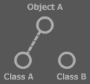 | After creation  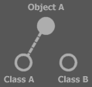

You can also specify an alternate type on creation.

Before creation | After creation  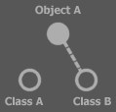

The alternative type, however must support the same interface. <2008-10-12 No it doesn’t. Only if the object had an interface assigned to it. > It may have completely the same interface:

Before creation  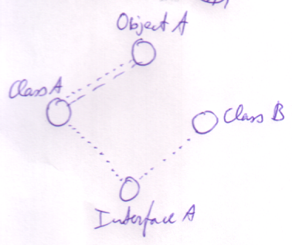 | After creation  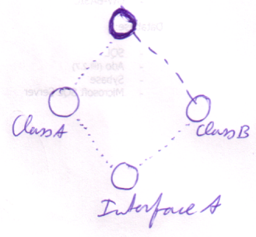

But the new type may also only support the interface of the type it had before the creation:

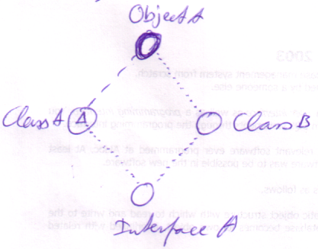
After Creation

< 2008-10-12 These ideas must have dated from when I thought that changing the diagram at runtime was rare. And that an object can not be created without having a class. >

What you see is that when you create an object giving it a different type, the diagram is actually changed at run time. If you use an alternate type when the symbol is created, its type line is changed. If the symbol did not yet have a type line, then it gets one.

Before creation  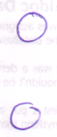 | After creation (specifying a type)  